**Client Account Team - Report Request Form for Recognize Dashboard**

**| Admin App**

**Table of Contents**

1. **Opening -up the Admin App** 3
2. **Configure Management Level Settings**3
3. **Requests Filtering Functionalities**4
   * 1. Using Search bar Filtering4
     2. Using All (Created Date) dropdown filters4
     3. Using All Status dropdown filters4
4. **Viewing Access Request Details**5
5. **Cancel or Revoke Access Request**5
   * 1. Cancel Access Request5
     2. Revoke Access Request6
6. **Version History**7
7. **Opening -up the Admin App**

* A screenshot of a computer

  Description automatically generated with medium confidenceOpen Admin App by clicking this link [Client Request Form - Admin - PowerApps](https://apps.powerapps.com/play/e/66d830c7-b955-487f-804f-818d2a1bd32a/a/7a9b84fe-25f0-4531-b6b2-a0da97a1a5bf?tenantId=e0793d39-0939-496d-b129-198edd916feb&source=portal).

1. **Configure Management Level Settings.**

* Click on Settings Icon, you will be redirected to Settings Page.

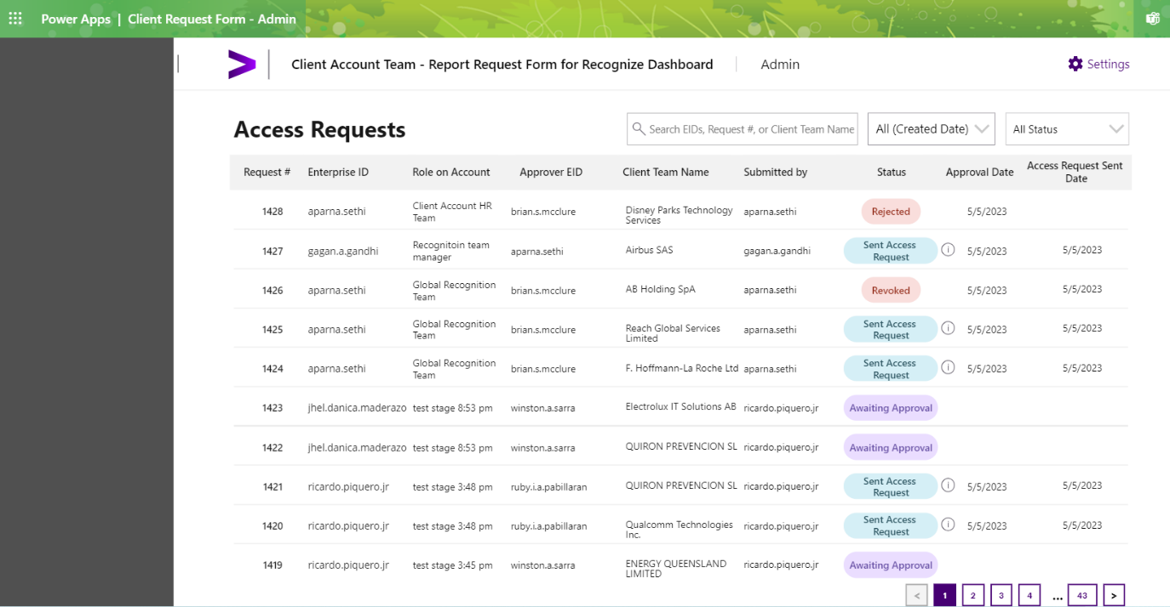

* Configure appropriate Management Level/s as Approver.
  + When Admin select Management Level/s and then click Save Changes button.

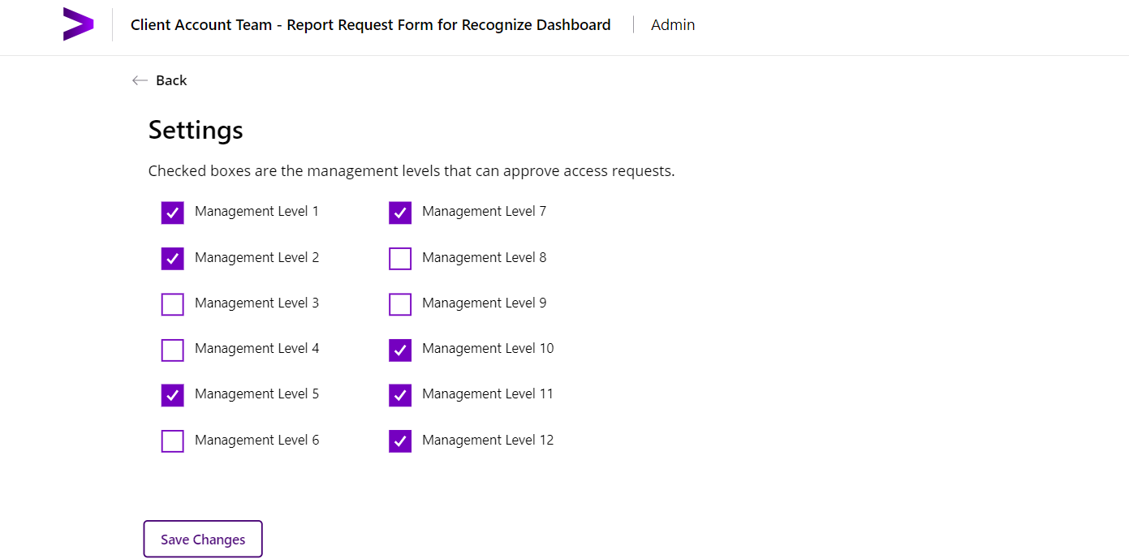

2

1

* + When Admin select Management Level/s but click the Back button instead of Save Changes button, as such a pop-up modal will appear to let you decide saving your changes or not.

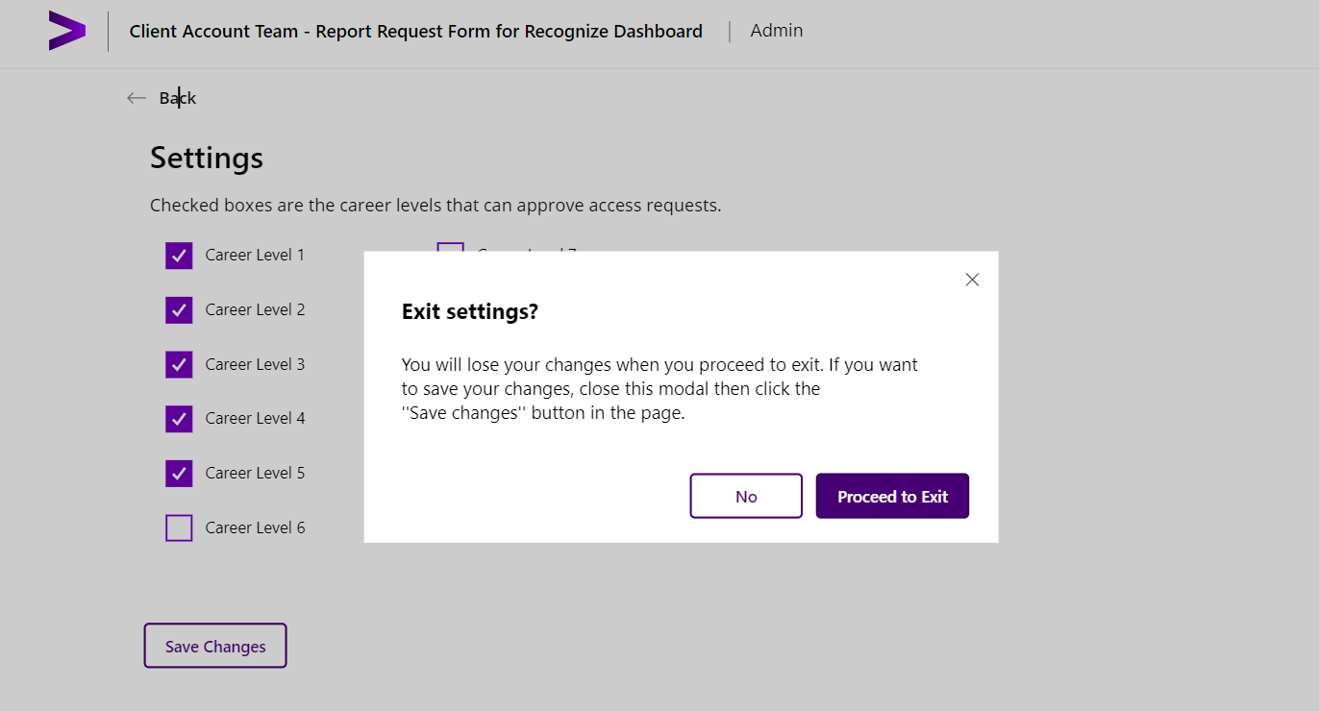

* + When Admin unselect all available Management Level/s, a verbiage error***“You have to select at least one management level.”*** will pop-up indicating that you should configure with at least a Management Level enabled.

1. **Requests Filtering Functionalities**
2. Using the Search bar to filter requests by *EIDs, Request #, or Client Team Name*.

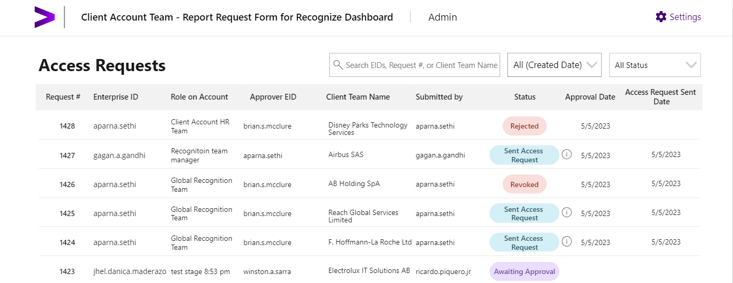

1. Using All (Created Date) dropdown filter with the following options: *This Week, This Month, Last 30 days, Last 3 months, Date Range.*

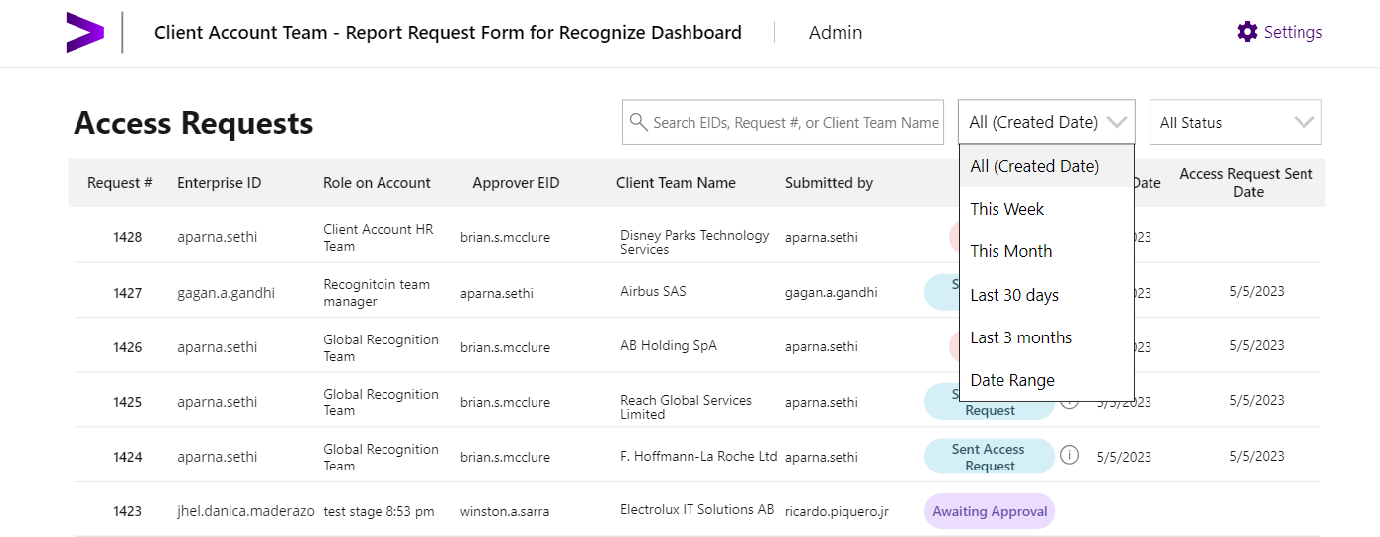

1. Using All Status dropdown filter with the following options: *Awaiting Approval, Approved, Rejected, Sent Access Request, Canceled, Revoked, Access Granted and Closed-no response*.

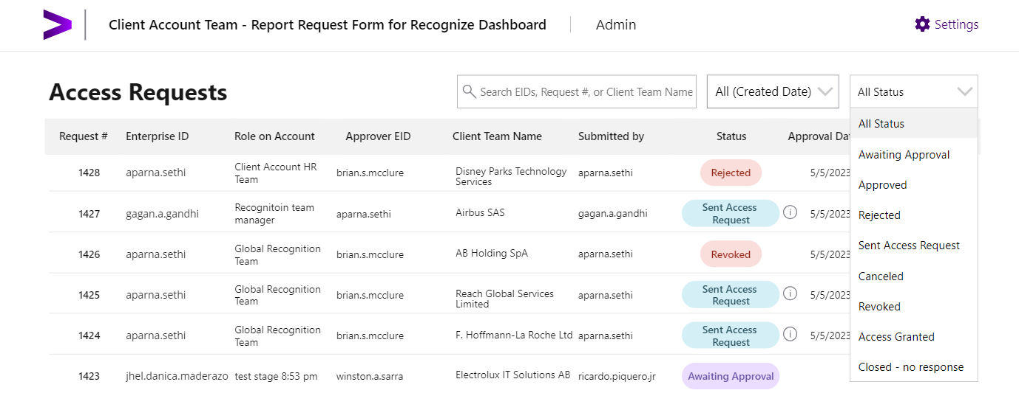

1. **Viewing Access Request Details**

View more details of specific access request by clicking within the row of your desired request.

* + **Approver Notes**: This field shows the notes when approver approves or reject the request.
  + **Enterprise ID**: This field shows the requestor’s Enterprise ID.
  + **Role on Account**: This field shows the requestor’s role on account.
  + **Reason for Access Request**: This field shows the reason why the requestor and/or request creator wants to have an Access Request.
  + **Approver Enterprise ID**: This field shows the approver’s Enterprise ID.
  + **Client Team Name**: This field shows the list of active Clients registered in the system.
  + **Created by**: This field shows the request creator’s EID.
  + **Created Date and Time**: This field shows the created date and time the request was logged.
  + **Approver Action Date & Time**: This field shows the date and time the approver approves or reject the request.
  + **Access Request Sent Date & Time**: This field shows the date and time the request was already for Work Human provisioning and access granting.

1. **Cancel or Revoke Access Request**

As an Admin, you could Cancel or Revoke an access request.

1. **Cancel Access Request**

You could cancel an access request when the request status is at *Awaiting Approval*.

[1] Click on item with Awaiting Approval status.

[2] Click on Cancel button.

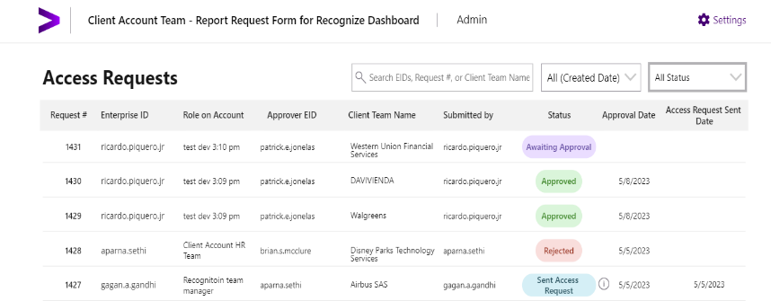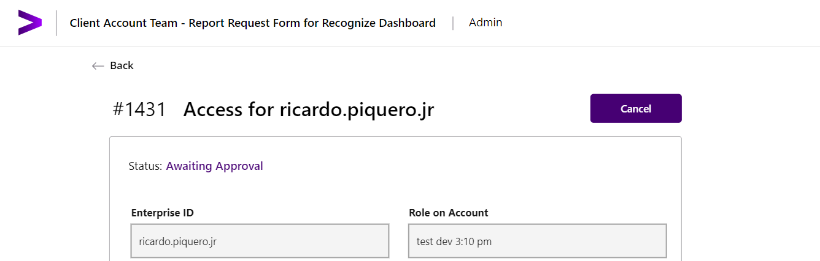

1

2

1. **Revoke Access Request**

You could revoke an access request when the request status is at *Sent Access request, Access Granted*.

[1] Click on item with Sent Access Request or Access Granted status.

[2] Click on Revoke button.

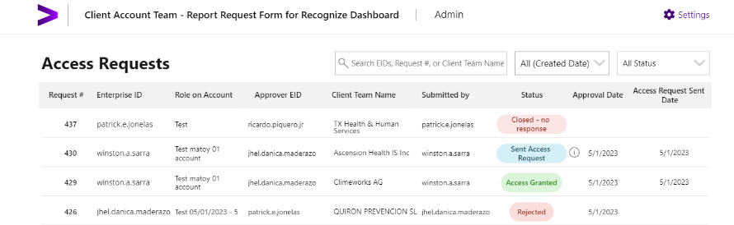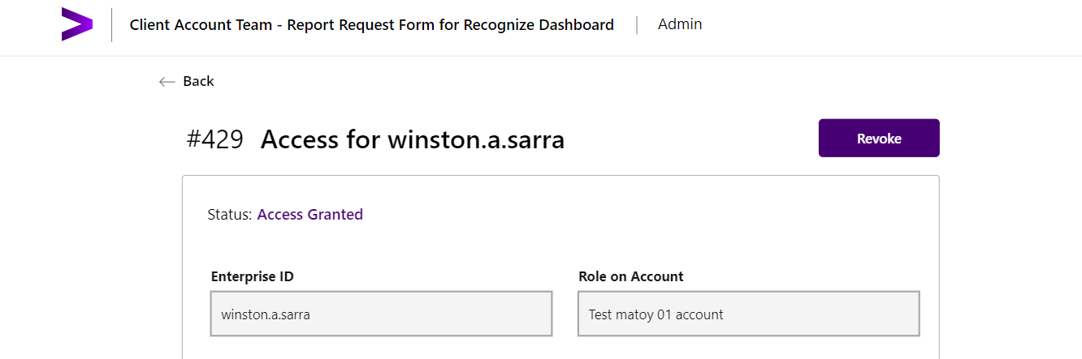

2

**Version History**

|  |  |  |  |  |
| --- | --- | --- | --- | --- |
| **Date** | **Version** | **Description** | **Prepared By** | **Reviewed By** |
| 05/10/2023 | 1.0 | The initial version of the Client Account Team - Report Request Form for Recognize Dashboard | Admin User Guide. | ricardo.piquero.jr |  |